第一题
clear,clc,close all;
i=zeros(250,239);
i(21:230,[21:27 45:51 69:75 93:99 117:123 141:147 165:171 189:195 213:219])=1;%生成图像
%生成均值滤波器
f1=ones(3,3)/9;
f2=ones(5,5)/25;
f3=ones(9,9)/81;
%滤波
I1=imfilter(i,f1,'conv','replicate','same');
I2=imfilter(i,f2,'conv','replicate','same');
I3=imfilter(i,f3,'conv','replicate','same');
%画图
subplot(2,2,1),imshow(i),title('原图');
subplot(2,2,2),imshow(I1),title('3X3均值滤波');
subplot(2,2,3),imshow(I2),title('5X5均值滤波');
subplot(2,2,4),imshow(I3),title('9X9均值滤波');
%保存图像
imwrite(i,'1.jpg');

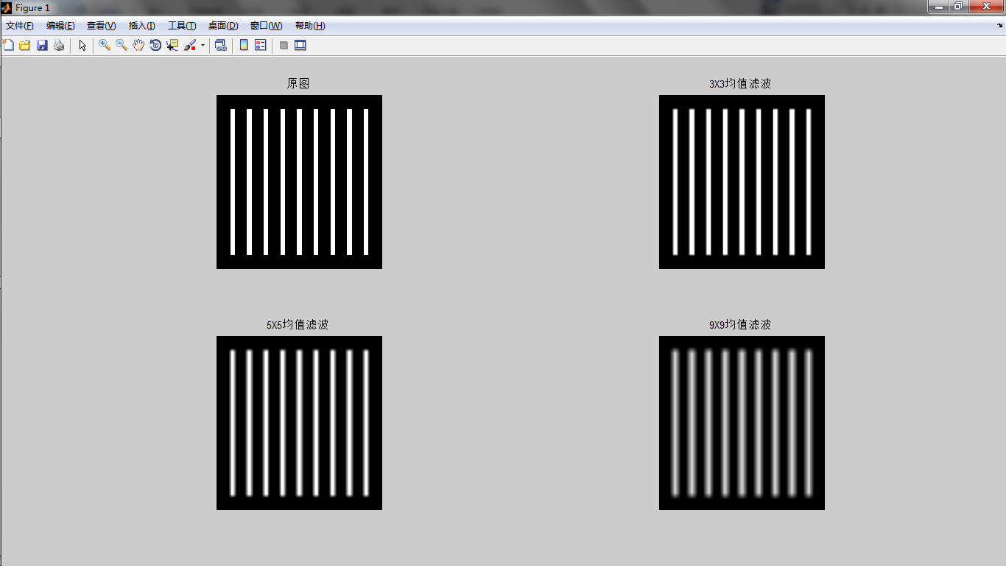

第二题
clear,clc,close all;
h=im2double(imread('1.jpg'));
[M, N]=size(h);
h1=zeros(M,N);h2=zeros(M,N);h3=zeros(M,N);h4=zeros(M,N);
%谐波均值滤波
for x=2:M-1
for y=2:N-1
g=0;
for i=x-1:x+1
for j=y-1:y+1
g=g+1/h(i,j);
end
end
h1(x,y)=9/g;
end
end
%逆谐波均值滤波
Q=-1.5;
for x=2:M-1
for y=2:N-1
g=0;G=0;
for i=x-1:x+1
for j=y-1:y+1
g=g+h(i,j)^(Q+1);
G=G+h(i,j)^Q;
end
end
h2(x,y)=g/G;
end
end
%最大值滤波
for x=2:M-1
for y=2:N-1
g=[];
for i=x-1:x+1
for j=y-1:y+1
g=[g,h(i,j)];
end
end
h3(x,y)=max(g);
end
end
%中值滤波
for x=2:M-1
for y=2:N-1
g=[];
for i=x-1:x+1
for j=y-1:y+1
g=[g,h(i,j)];
end
end
g=sort(g);
h4(x,y)=g(5);
end
end
%画图
subplot(2,3,1),imshow(h),title('原图');
subplot(2,3,2),imshow(h1),title('谐波均值滤波');
subplot(2,3,3),imshow(h2),title('逆谐波均值滤波');
subplot(2,3,4),imshow(h3),title('最大值滤波');
subplot(2,3,5),imshow(h4),title('中值滤波');
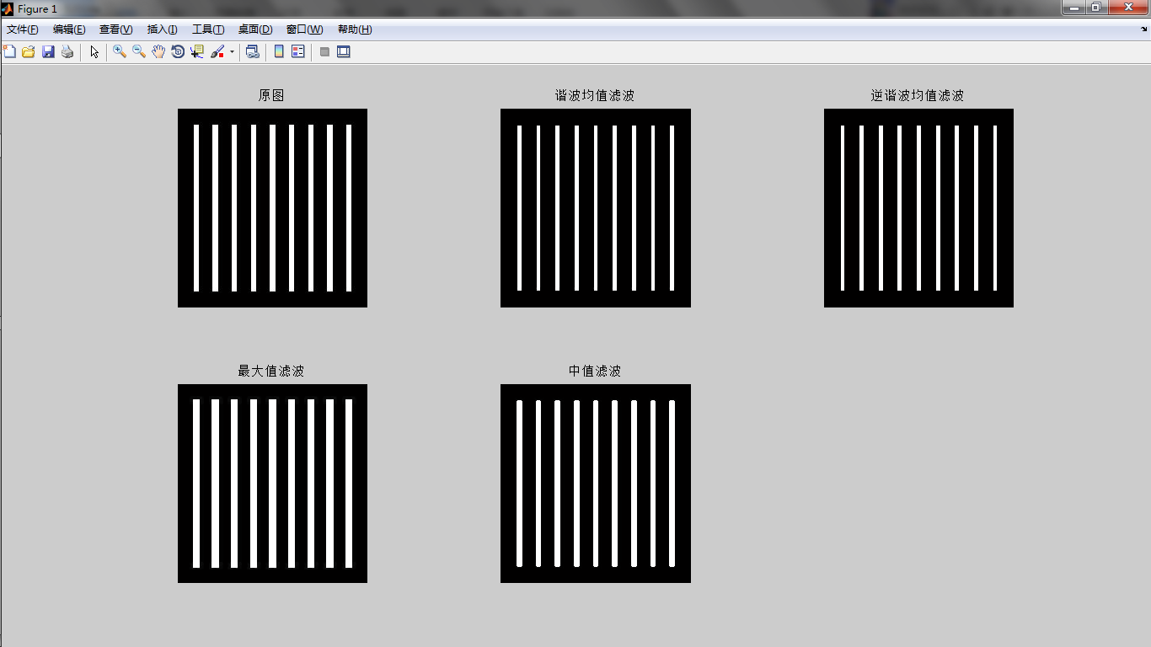

第三题
clear,clc,close all;
I=im2double(rgb2gray(imread('art.jpg')));
[M,N]=size(I);
PSF=fspecial('motion',100,45);%生成点扩展函数
%空域滤波
I1=imfilter(I,PSF,'conv','replicate','same');
%频域滤波
OTF=fftshift(fft2(PSF,M,N));
fft_I=fftshift(fft2(I));
fft_I2=OTF.*fft_I;
I2=ifft2(fftshift(fft_I2));
%画图
subplot(2,3,1),imshow(I),title('原图');
subplot(2,3,2),imshow(mat2gray(PSF)),title('PSF');
subplot(2,3,3),imshow(I1),title('空域滤波结果');
subplot(2,3,4),imshow(I),title('原图');
subplot(2,3,5),imshow(mat2gray(abs(OTF))),title('OTF');
subplot(2,3,6),imshow(I2),title('频域滤波结果');
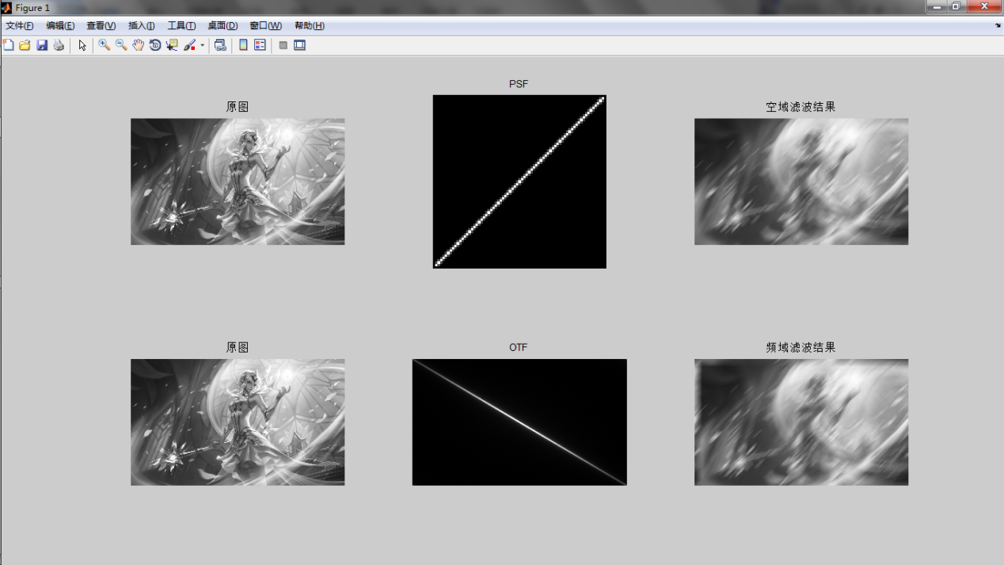

第四题
clear,clc,close all;
i=im2double(rgb2gray(imread('image.jpg')));
[M,N]=size(i);
%加入运动模糊
[u,v]=meshgrid(1:N,1:M);
u=u-M/2;
v=v-N/2;
T=1.0;a=0.05;b=0.05;
z=pi*(u*a+v*b)+eps;
H=T./z.*sin(z).*exp(-1j*z);
fft_i=fftshift(fft2(i));
fft_i1=H.*fft_i;
i1=abs(ifft2(fftshift(fft_i1)));
%加入高斯噪声
i2=imnoise(i1,'gaussian',0.01,0.002);
fft_i2=fftshift(fft2(i2));
%全逆滤波
F1=1./H;
fft_I1=F1.*fft_i2;
I1=abs(ifft2(fftshift(fft_I1)));
%半径限制的逆滤波
F2=zeros(M,N);
for m=1:M
for n=1:N
if sqrt((m-M/2)^2+(n-N/2)^2)<=14
F2(m,n)=1./H(m,n);
else
F2(m,n)=0;
end
end
end
fft_I2=F2.*fft_i2;
I2=abs(ifft2(fftshift(fft_I2)));
%维纳滤波
k=0.1;
F3=(1./H).*(abs(H).^2)./((abs(H).^2)+k);
fft_I3=F3.*fft_i2;
I3=abs(ifft2(fftshift(fft_I3)));
%画图
subplot(2,3,1),imshow(i),title('原图');
subplot(2,3,2),imshow(i1),title('模糊图像');
subplot(2,3,3),imshow(i2),title('加噪图像');
subplot(2,3,4),imshow(I1,[]),title('全逆滤波复原图像');
subplot(2,3,5),imshow(I2,[]),title('半径限制的逆滤波复原图像');
subplot(2,3,6),imshow(I3,[]),title('维纳滤波复原图像');
